There is a moderately strong relationship between the subjective ratings of how likely people were to choose experiences involving family over experiences involving friends and their performance on the task (r=0.612, p<.001).

| **Correlation Matrix** | | | | | | | |
| --- | --- | --- | --- | --- | --- | --- | --- |
|  |  |  |  |  |  |  |  |
|  | |  | | **fam over friends** | | **%chosen fam over friends** | |
| fam over friends |  | Pearson's r |  | — |  | 0.612 |  |
|  |  | p-value |  | — |  | < .001 |  |
| %chosen fam over friends |  | Pearson's r |  |  |  | — |  |
|  |  | p-value |  |  |  | — |  |
|  | | | | | | | |

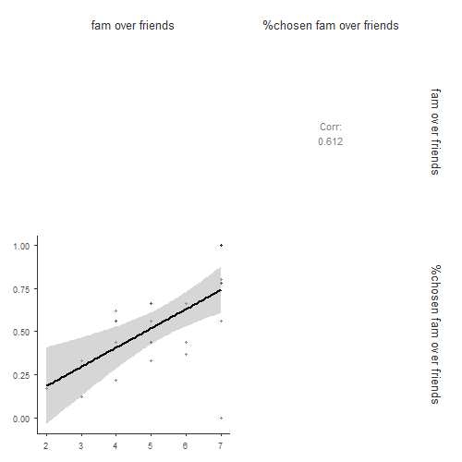

There is a moderately strong relationship between the proportion of times subject chose social media experiences, and scores on the Network Management subscale of the Social Support on Social Networking Sites measure (r=0.443, p=0.023)

| **Correlation Matrix** | | | | | | | |
| --- | --- | --- | --- | --- | --- | --- | --- |
|  |  |  |  |  |  |  |  |
|  | |  | | **%chosen social media** | | **sssn network mgmt** | |
| %chosen social media |  | Pearson's r |  | — |  | 0.443 |  |
|  |  | p-value |  | — |  | 0.023 |  |
| sssn network mgmt |  | Pearson's r |  |  |  | — |  |
|  |  | p-value |  |  |  | — |  |
|  | | | | | | | |

